Lesson 20

**Git and working with the command line**

Level 1

Create a repository on GitHub.

Add folders with the names of the previous lessons. In each folder, place the files with the completed assignments for the corresponding lesson.

<https://github.com/N0vocaine/Homework>

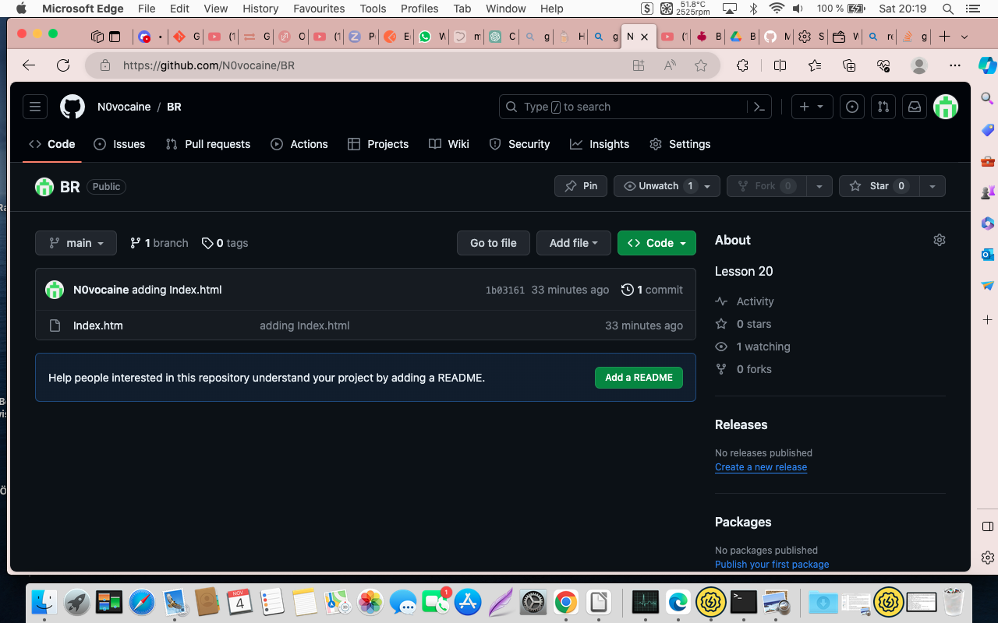

Create a new repository on GitHub:

* clone it to a local repository;
* create an index.html file in the local repository;
* write a simple structure with key HTML tags in index.html;
* send the changes from the local repository to the remote one;
* attach a link to the remote repository and screenshots of the performed commands in LMS.

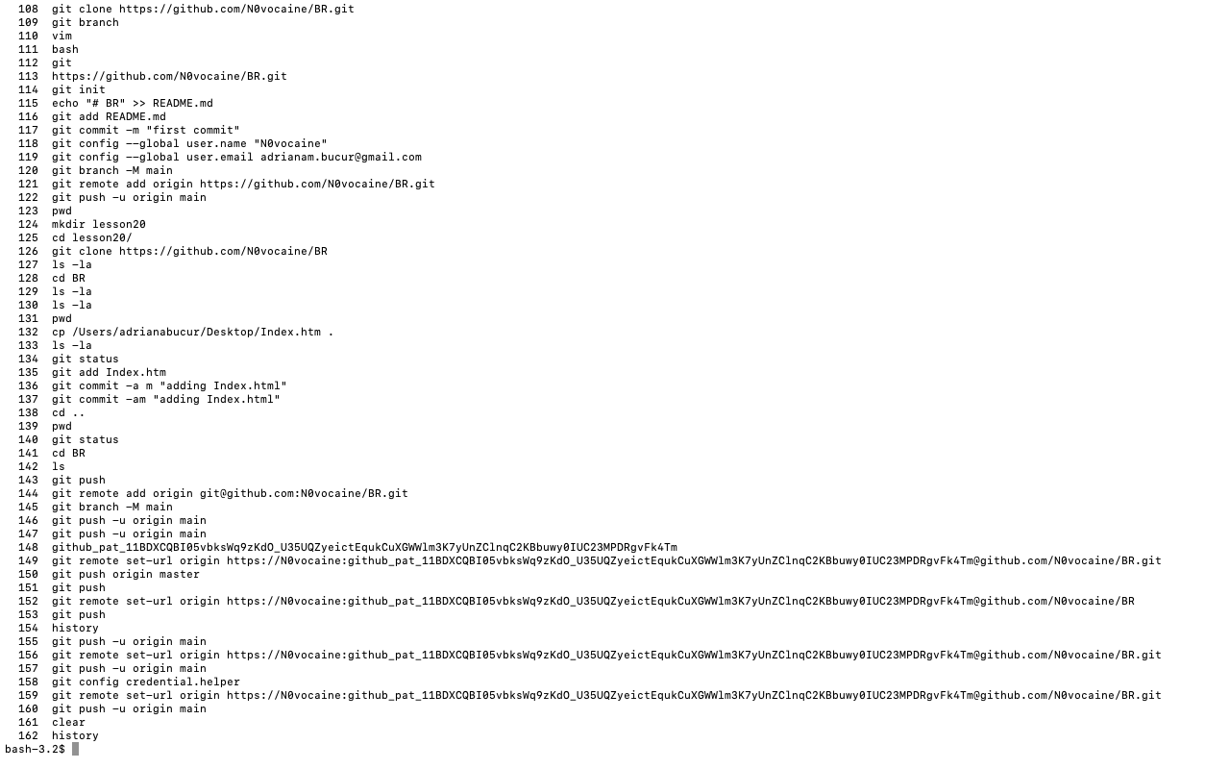

Using the Bash shell’s CLI, perform the following actions:

* in your home directory, go to the Downloads directory
* create a GitLesson directory in it
* create a file called file1.txt in the Downloads directory
* write in file1.txt the text "Hello, world!" and save the changes
* display the contents of file1.txt on the screen
* copy file1.txt from the Downloads directory to the GitLesson directory and display the contents of the GitLesson directory
* add screenshots of the result of each command to LMS.

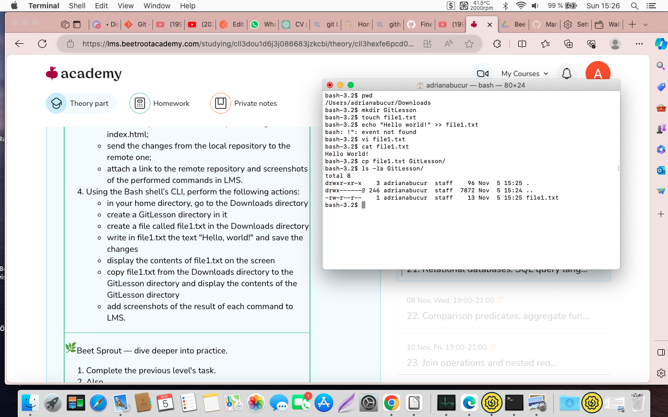

Level 2

Also,

* in the previously created remote repository on GitHub, create a "README" file;
* pull changes from the remote repository to the local one;
* write down 5 links to the checklists, test cases, bugs (saved on Google Drive or any other external resource) created in the created "README" file;
* push the changes to the remote repository;
* link the remote repository and add screenshots of the performed commands to LMS.

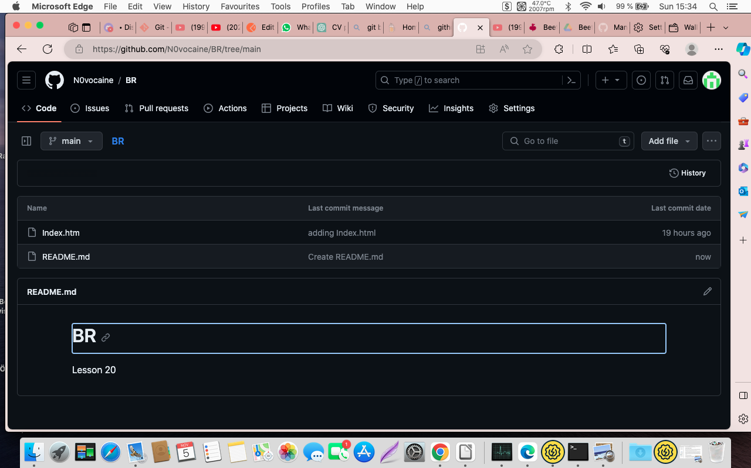

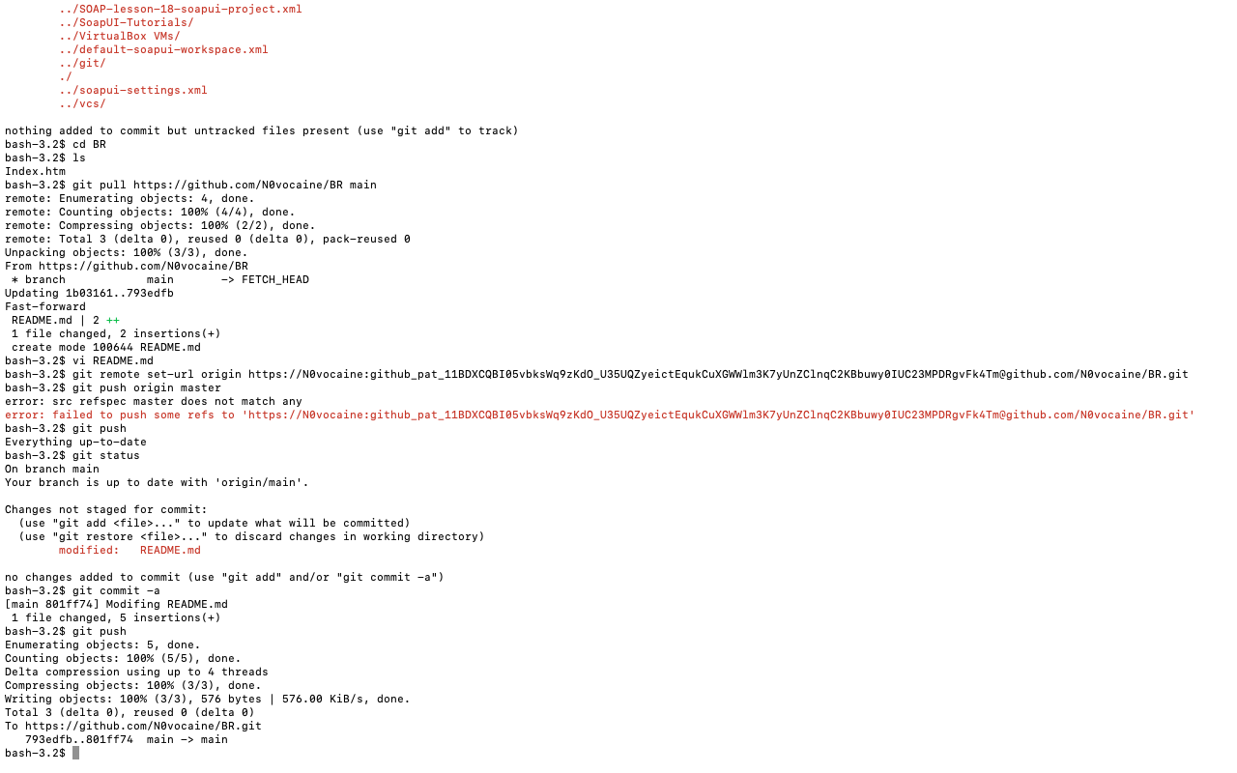

Finally,

* in the Downloads directory, create the file "script1.sh";
* write 3 commands to this file: the first one prints Hello world, the second one prints the path to the current directory, and the third one prints the current date;
* move the created file to the GitLesson directory;
* in the Downloads directory, run the previously created file "script1.sh";
* add screenshots with the result of each command to LMS.

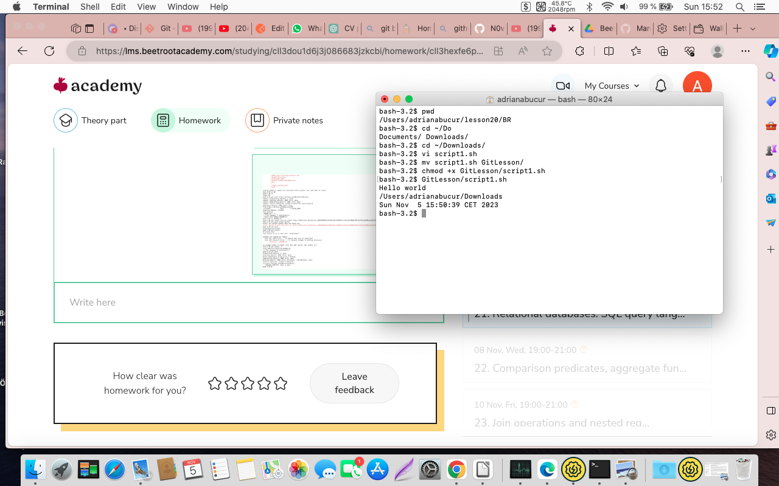

Level 3

Then, complete the following actions:

* in the local repository, create a new branch (with any name);
* in the created branch, add a folder called "MyWork" where you will put files containing checklists, test cases, and bugs from the previous task;
* edit the "README" file so that the links in it do not lead to external resources, but to files saved in the MyWork folder (you need to use a relative path to the file, not an external link to it);
* merge this branch into the main branch;
* push the changes to the remote repository;
* link the remote repository and add screenshots of the performed commands to LMS.

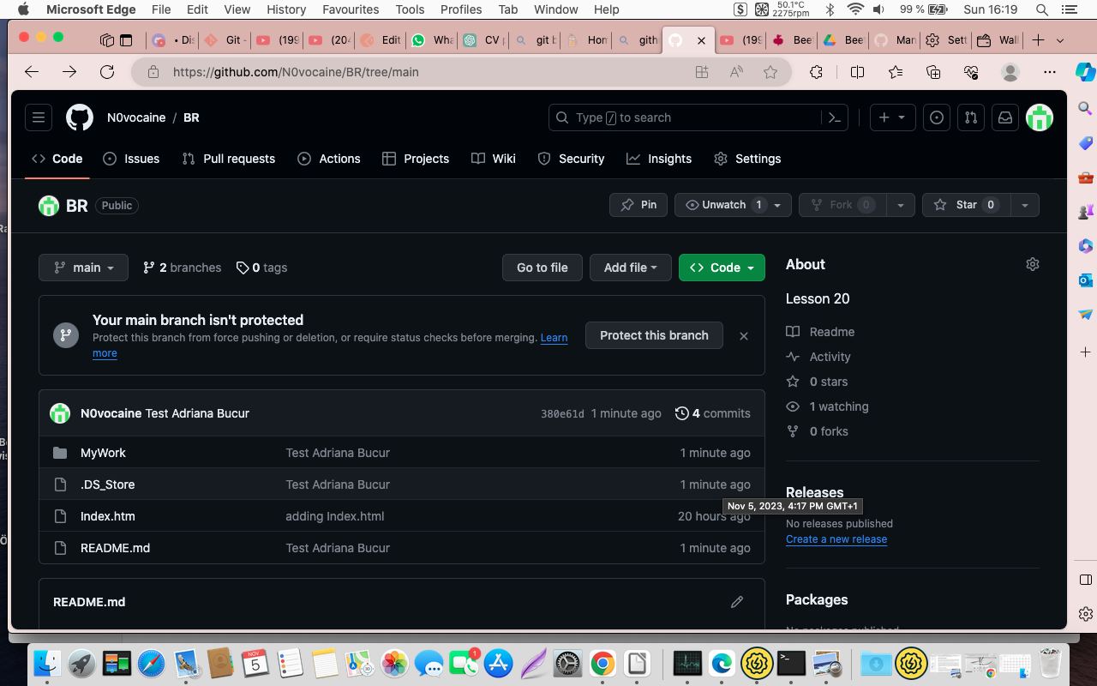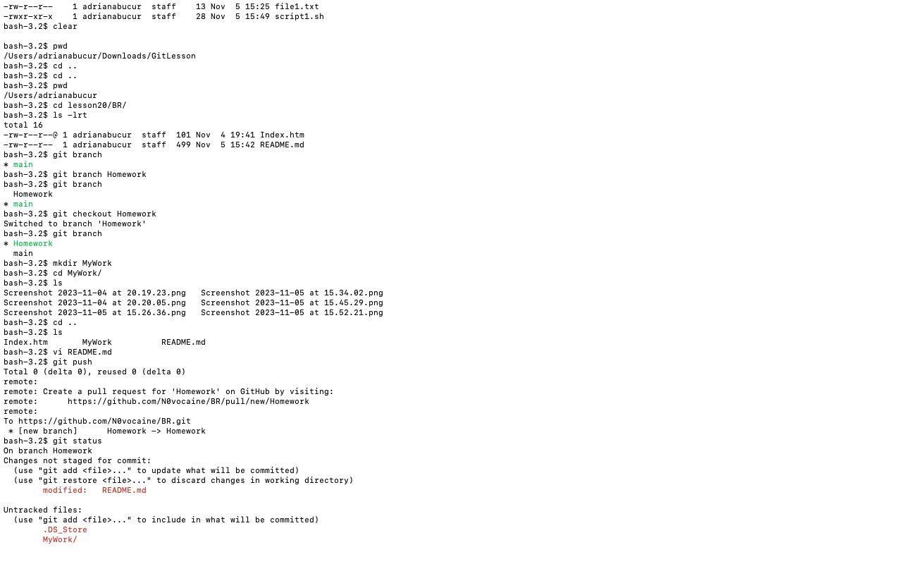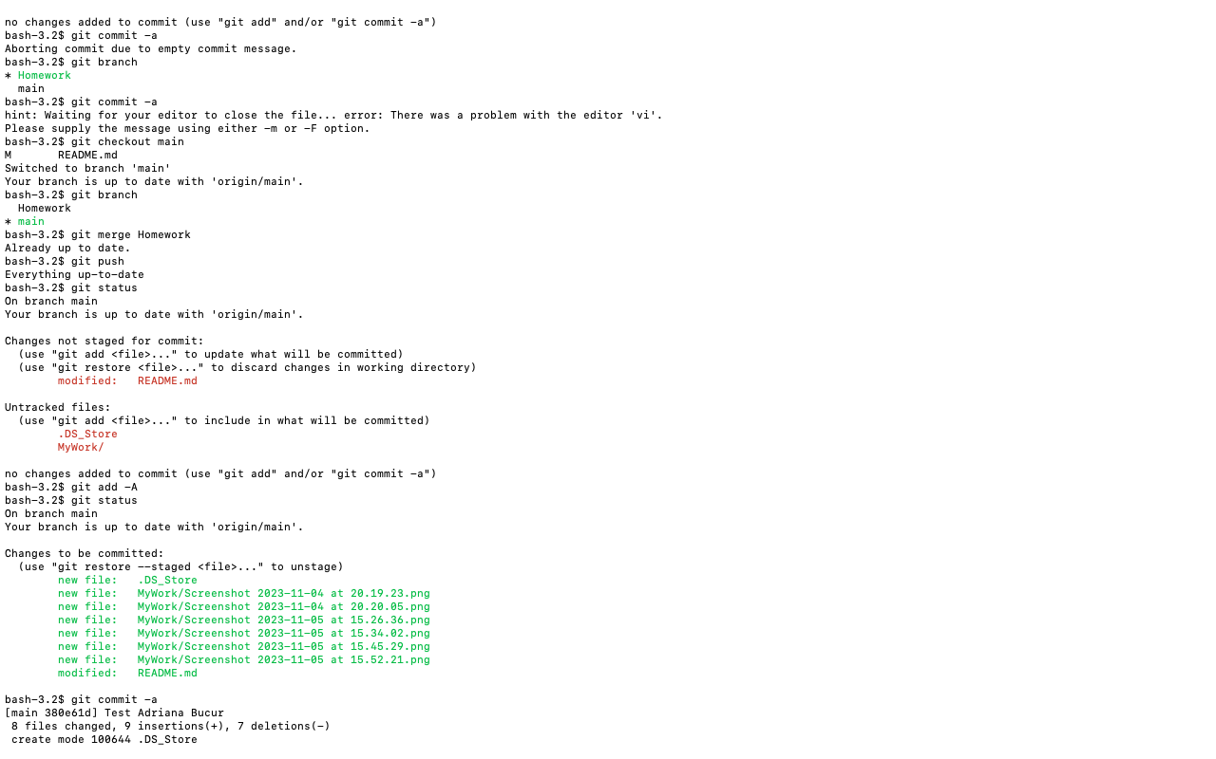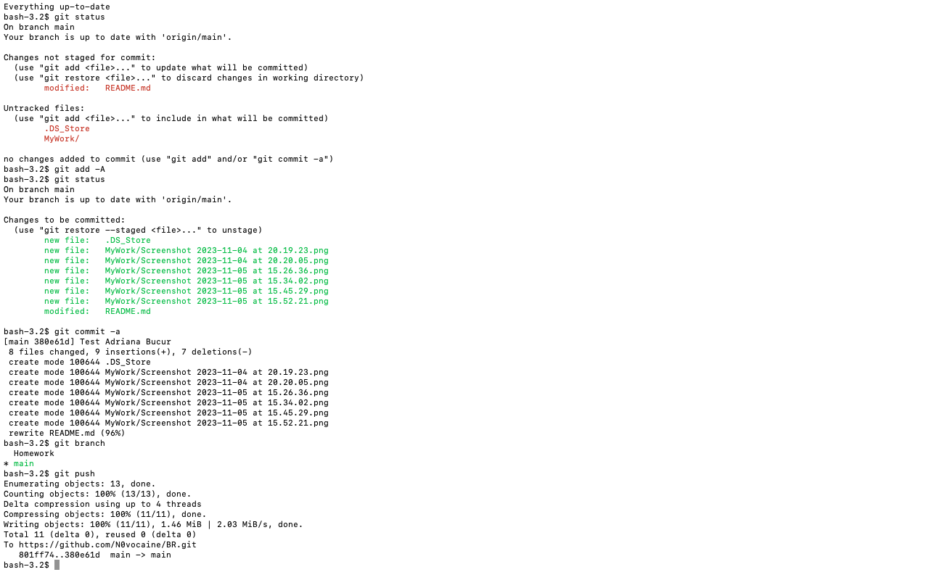

Last but not least,

* in the Downloads directory (GitLesson folder), rename "file1.txt" to "script2.sh";
* remove the text from "script2.sh" and write a command that displays the current time every 2 seconds for 10 seconds;
* execute "script1.sh" and "script2.sh" in one command;
* delete the "MyWork" directory with all its contents;
* check if the directory is deleted;
* add screenshots with the result of each command to LMS.

